Mind-controlled application
Patrik Berger*
Slovak University of Technology in Bratislava
Faculty of Informatics and Information Technologies
Ilkovičova 2, 842 16 Bratislava, Slovakia
xbergerp@fiit.stuba.sk
The computers have become a part of our everyday life, interaction with them is carried out mainly through the well-known ways that are mouse and keyboard. Recent progress in BCIs (brain-computer interfaces) offers an alternative. Most of the BCI systems nowadays use EEG devices to acquire the brain signal.
One of the major tasks for BCIs is to correctly interpret the acquired brain signal. The signal itself is the result of a very complex brain activity, which we do not fully understand yet. Furthermore, the acquiring ability of EEG device is limited and the signal contains a noise created by electric potentials from different parts of the body, such as eye blinks, muscle activity, or even heart beats [3].
Currently, there are three mental activities that can be presently identified with BCI applications [1]:
- concentration
- stimulus response
- imagined movement

Most of the research in that area and also our work is focused on the stimulus response. There is a technique called Oddball paradigm commonly used in the stimulus response based applications [2]. It uses target and non-target elements shown to a subject in a random order with about 80% probability of the non-target and 20% for the target element. A participant is instructed to do a mental activity such as counting occurrences every time the target element appears. That creates event-related potential (ERP) wave called P300.
In our work, we propose an EEG signal processing method in order to recognize P300 (see Figure 1). It includes selecting channels (electrodes), filtering the signal to get rid of the noise and final classification of the processed signal. We mainly focus on the channel selection part, where we propose a genetic algorithm (GA) combined with the linear discriminant analysis (LDA) to select the best subset of the channels. We want to find out whether our method will be effective enough to recognize P300 even with a low-cost EEG device like Emotiv Epoc and if so, what accuracy we can get. We also want to compare our GA-based channel selection method with using all channels and with using the recursive channel elimination method, which should be able to find to the best subset (and, therefore, will be used as our baseline). We hypothesize that accuracy while using our channel selection method will be significantly better than using all channels and slightly worse but faster than recursive approach. We also assume that our method should be able to recognize P300 from the Epoc data. 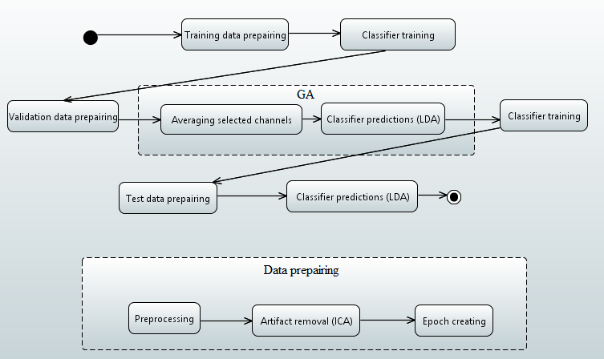

Amended/Extended version was published in Proc. of the 10th Student Research Conference in Informatics and Information Technologies (IIT.SRC 2016), STU Bratislava, xx-xx.

Acknowledgement: This contribution was created with kind support of ČSOB Foundation and is partial result of the project University Science Park of STU Bratislava, ITMS 26240220084, co-funded by the ERDF.

References
- Ferreira, A.L.S. et al.: A Survey of Interactive Systems based on Brain-Computer Interfaces. SBC Journal on 3D Interactive Systems, (2013), vol. 4, no. 1, pp. 3–13.
- Hoffman, A.: EEG Signal Processing and Emotiv’s Neuro Headset. Bachelor Thesis (2010).
- Ondráček, O. et al.: Číslicové spracovanie signálov. Biosignály. (in Slovak). STU Press, Bratislava, (2007), pp. 313.

* Supervisor: Róbert Móro, Institute of Informatics and Software Engineering

