Learning by playing: generated programming exercises to teach programming the innovative way
Peter KIŠ*
Slovak University of Technology in Bratislava
Faculty of Informatics and Information Technologies
Ilkovičova 2, 842 16 Bratislava, Slovakia
koritnak@gmail.com
Lack of motivation of students is one of the main barriers to efficient learning [1]. In the case of online learning there are also suppressed natural human and social aspects, so the lack of motivation causes even worse results. Therefore, research is still looking for new ways to increase students’ motivation for learning online. Games and gaming principles improve entertainment and increase overall involvement of students [2]. Both of them are increasingly used in the online environment. Use of games and game principles, graphical visualization, and entertainment content for teaching programming opens the way to explore the impact of these elements in the learning process, the speed of acquiring new knowledge and the ability to select the most appropriate procedures for solving algorithmic problems [3].
Considering the typical source code writing exercises are already well implemented in teaching programming, we decided that in our work we will focus on creating novel types of programming exercises through the use of existing codes that students produced over the past years. For new students, we want to prepare a diverse range of tasks from these codes, aimed on the understanding, analysis and description of the code, the code refactoring and use of best practices in programming. We plan to include these innovative tasks into created environment, designed to let students compete against each other.
This work is focused on creating games or the use of gaming techniques and principles in the online environment to support learning. The main objective of this work was to create educative game, which by their nature and offered tasks propose new, engaging and students accepted form of education along conventional teaching style. We present motivation as one of the factors influencing the process of learning. As an option to achieve enhancing students' motivation for the study is an approach using games. We present games as support, but also as a source of motivation to learn new things. The result of the analysis is the creation of educational environment (Figure 1) with and interactive format tasks automatically generated from existing source code that students created for school assignments on selected subjects.
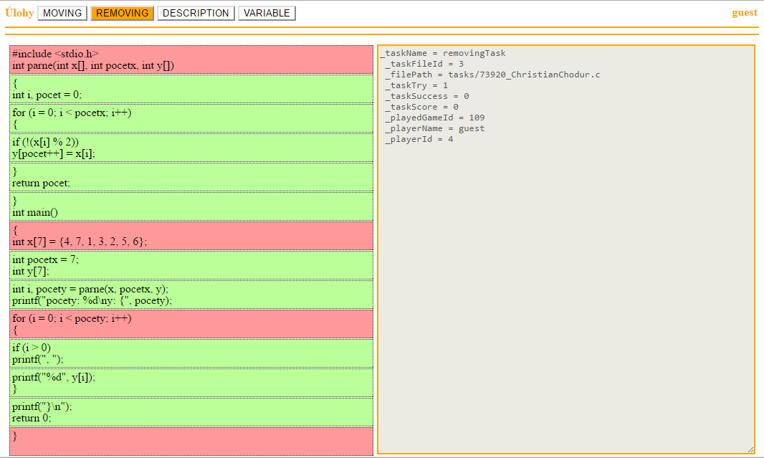
Figure 1 Screen of prototype while Removing task was played.

In the experiment, we plan to acquire multiple data describing level of students' knowledge of programming in language C and evaluate the benefits of our games on their knowledge. Likewise, we want to get feedback from students on individual tasks and identify those with the biggest benefit when used in the educational process.

Amended/Extended version was published in Proc. of the 10th Student Research Conference in Informatics and Information Technologies (IIT.SRC 2014), STU Bratislava, xx-xx.

Acknowledgement. This work was partially supported by the..

References
- Angela Carbone , John Hurst , Ian Mitchell , Dick Gunstone, An exploration of internal factors influencing student learning of programming, Proceedings of the Eleventh Australasian Conference on Computing Education, January 01-01, 2009, Wellington, New Zealand
- Allan Fowler , Brian Cusack, Kodu game lab: improving the motivation for learning programming concepts, Proceedings of the 6th International Conference on Foundations of Digital Games, p.238-240, June 29-July 01, 2011, Bordeaux, France
- Michael J. Lee , Andrew J. Ko, Personifying programming tool feedback improves novice programmers' learning, Proceedings of the seventh international workshop on Computing education research, August 08-09, 2011, Providence, Rhode Island, USA

* Supervisor: Jozef Tvarožek, Institute of Informatics and Software Engineering

