Presentation of Personalized Recommendation via Web

Martin Svrček[1]*

Slovak University of Technology in Bratislava

Faculty of Informatics and Information Technologies

Ilkovičova 2, 842 16 Bratislava, Slovakia

mato.svrcek@gmail.com

Recommender systems are software tools and techniques which are designed to provide a suitable items that may be helpful to the user [1] and thus simplified the selection of appropriate information. However, a serious problem that prevents even more widespread of recommendations is often distrust of users. An interesting approach to reduce such a problem is the form of explanation of recommendations.

Explanations are oriented directly to users and trying to provide the reasons why the recommendation could be useful to them [2] and they also focus on building trust of users. Our main goal is therefore to reduce the distrust of users in recommendation systems and also to increase transparency and attractiveness of recommendations. In the context of these goals, we have decided to propose our explanation method whose characteristics are:

* Method is a personalized type of explanation of recommendations directed to user.
* Method is independent to recommendation technique.

Proposed method is hybrid type of personalized explanation. This means that this method combines different approaches for explanation in order to achieve the best result. For each recommended article is necessary to find explanation that is suitable in the context of characteristics of this article and which is also suitable for the user.

Method uses two basic sources of data (Figure 1). The first are recommended articles together with their characteristics or keywords. The second are information about users represent by user model. The actual explanations are generated based on the method of personalized explanation which use three approaches:

* Explanation based on collaboration
* Explanation based on the content of articles
* Explanation based on the knowledge of users

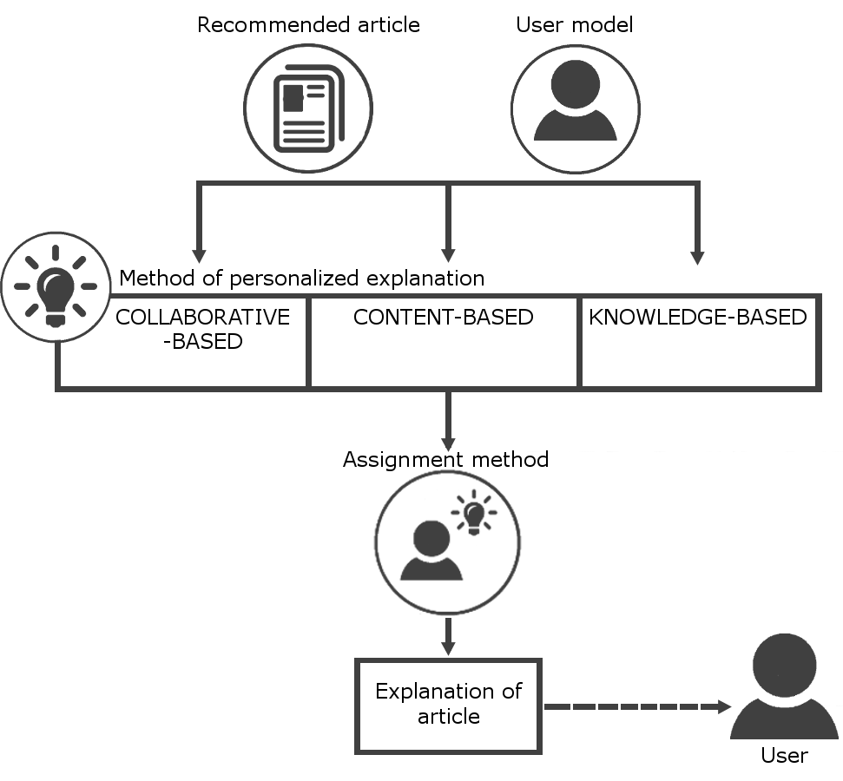

Figure 1. Model of personalized explanation.

The next step of proposed approach is to decide which type of explanation is appropriate for the current user. This is the task for the assignment method. The basic phase of this step is a learning phase where we select all explanation approaches in the same ratio. In this phase, we ordered the results of these approaches in a standard way called the interleaving. Our goal is to learn which type of explanation is preferred by each user.

The main goal of the personalized explanation is mainly to reduce the distrust of users in recommendation systems. However a necessary condition to achieve the goal is also to generate explanations suitable for the user. In order to evaluate our approach, we will conduct an uncontrolled long-term experiment motivating the participants to read articles in our system.

In case of reduction of distrust we want to evaluate our approach in a simple way by compare the results of standard and personalized explanations. We will evaluate which of the articles (explained standard or personalized way) were viewed more. In case of accuracy of personalization of explanations we want to verify our approach by interleaving the results of three different approaches to personalized explanations. Thus we will learn which type of explanation is preferred by each user.

*Acknowledgement.* This work was partially supported by the Scientific Grant Agency of Slovak Republic, grant No. VG 1/0774/16.

# References

1. Ricci, F., Rokach, L., Shapira, B.: *Introduction to recommender systems handbook*. Springer US, 2011.
2. Tintarev, N., Masthoff, J.: *Evaluating the effectiveness of explanations for recommender systems*. User Modeling and User-Adapted Interaction, 2012.

1. * Supervisor: Michal Kompan, Institute of Informatics and Software Engineering