Support of student's activity in an e-learning system
Veronika Gondová*
Slovak University of Technology in Bratislava
Faculty of Informatics and Information Technologies
Ilkovičova 2, 842 16 Bratislava, Slovakia
xgondovav@stuba.sk
Education is an essential part of life for young people. The main problem in this field is a low motivation of students associated with a low activity of students. In accordance with this fact that motivation is the source of any human activity it is necessary to support it in this domain too. Gamification by Zichermann and Cunningham can increase student's motivation until 40% [3]. Whereas our aim is to increasing the activity of students, we provide game mechanics that will correspond to the needs of students. Personalization of game mechanics can cause an increase in student's satisfaction [1,2] and reduction of student's cognitive load that has an impact in the number of the overall activity of students.
The concept of gamification is not new. There are many systems that use gamification to support a motivation of users. For this purpose they use different mechanisms such as leaderboards, points, levels or badges.
Existing approaches use levels as a means to expression of progress, however, there is also the potential for use them as a tool for navigation while the original concept is exactly used for the motivation. In order to support the activity of students in the system we propose the method of navigation in personalized items. Our method is based on dynamic personalized distribution of items into smaller groups called rooms and navigation between these groups. Selection of items into the rooms is realized through personalized recommendation of items.
Our concept of navigation based on rooms supports the principles of gamification. The groups of items are the equivalents of levels in games. The rooms are perceived as complete complex tasks that are prepared to be solved. The navigation itself is an essential part of gameplay design. Advancement to the next room is conditional on obtaining the necessary success and activity in the current room.
Our approach is based on two smaller concepts that complement each other and together they create gameplay design. This includes the concept of rooms and concepts of navigation.
Our main aim is to increase the activity of students in an educational system. For this reason we propose a distribution of items into smaller sets called rooms which reduce cognitive overload and in consideration of their gaming character they support the activity of students. The distribution of items is realized dynamically in response to the activity of the student and it is based on personalized recommendation of items rooms separately for each student top N items for a particular recommenders.
The navigation between the rooms is created with rooms as a basis for the gameplay principle, where the main motivation element is based on the gradual opening of rooms. At the beginning of the week each student has available the only room. Achieving the necessary success rate and activity in the current room is a condition for the opening of the next room. Each room can be used to open a new one no more than once. The student has always available no more than just one room which is suitable for opening the new room and the set of open rooms from the actual week. When a student answers all the items in the room then the evaluation of try is shown to the student. If the student is active enough he opens a new room otherwise he has to answer the items in the room again (Figure 1). The actual progress in activity is shown to students through a progress bar. Success of try is determined by comparing the two types of scores: limit score and score of current try.
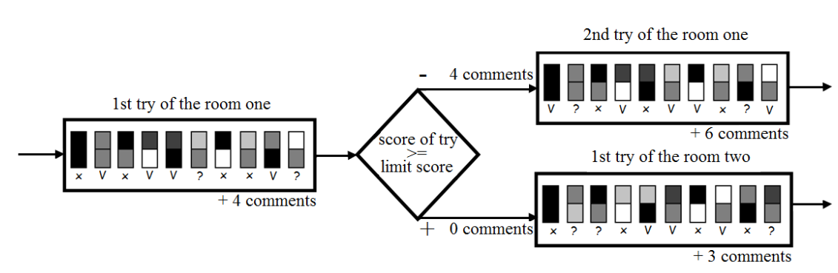
Figure 1. Principle of personalized navigation between the rooms.
Extended version was published in Proc. of the 12th Student Research Conference in Informatics and Information Technologies (IIT.SRC 2016), STU Bratislava, xx-xx.

References
- Ferrer, F.: Personalisation of Education. In: Personalisation of Education in Contexts,
SensePublishers, 2012. pp. 109-127.
- Liang, T., Lai, H., Ku, Y.: Personalized content recommendation and user satisfaction: Theoretical synthesis and empirical findings. In: Journal of Management Information Systems, 2006. pp. 45-70
- Zichermann, G., Cunningham, C.: Gamification by design : implementing game mechanics in web and mobile apps. Sebastopol, Calif: O'Reilly Media, 2011, pp. 35-66.

* Supervisor: Mária Bieliková, Institute of Informatics and Software Engineering

