Robust Detection of User's Cognitive Load Using Personalized Pupillary Response Model
Tomáš JUHANIAK*
Slovak University of Technology in Bratislava
Faculty of Informatics and Information Technologies
Ilkovičova 2, 842 16 Bratislava, Slovakia
juhaniak.tomas@gmail.com
Measuring of cognitive load can be done by plenty of ways, but it is important to make it non-intrusive and in real time. If we want evaluate real applications, we need a tool with an ability to measure cognitive load in complex long-term tasks, with big amount of participants, without requirements of human expert or laboratory environment (except keeping eye-tracker). Moreover this all have to be done fully-automated for arbitrary real, non-preprocessed tasks.
Eye-tracking is non-intrusive method for evaluating in field of human-computer interaction, and if we admit less fidelity it is usable out of laboratory environment. Especially the pupil diameter provides information about the cognitive load in every moment instead of other cumulative methods [1]. This helps in situations, when we cannot define margins of tasks but only their center. This technique seems as a best-fit universal and robust candidate for non-intrusive measuring of the cognitive load.
Pupil dilation (as result achieved by eye-tracking) in its own accord does not need to signalize cognitive load, moreover under some special conditions, a situation can occur when the pupil will contract and the cognitive load increases concurrently. Among all factors influencing dilatation, the most problematic is the changing luminosity of the screen content [2]. If we want to successfully filter out luminosity, we have to know how the heterochromous parts of the stimuli influence the dilatation of a pupil depending on the fixation area. There has not been much effort put into researching this field so far.
The contribution of our work is a method for evaluating cognitive load based on personalized pupillary response model (PPR model) and absolute values of pupil diameter. This goal can be achieved with calibration of PPR model on many stimuli with different luminosity values. Next, while the tested person work on their tasks, we record the presented stimuli and compute their luminosity with consideration of the fixation area. With the help of PPR model, we predict the actual pupil diameter or the trend of pupil dilation. The difference between measured and predicted values is filtered out according to psychological factors as is shown in figure below.
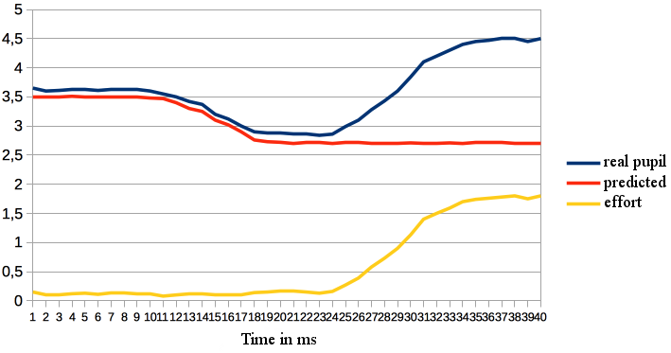
We found that the range of reference curve exceeded one millimeter for every tested person. We found, that standard error of predicted pupil diameters will not exceed 20% of the luminosity dilation range in plain and complex stimuli too and cognitive dilation range seems to be almost the same as the luminosity, our dynamic method can attempt to distinguish at best 5 levels of cognitive load.
Amended version was published in Proc. of the 12th Student Research Conference in Informatics and Information Technologies (IIT.SRC 2016), STU Bratislava, xx-xx.

References
[1] Chen, S., Epps, J., Chen, F.: A comparison of four methods for cognitive load measurement. In: Proceedings of the 23rd Australian Computer-Human Interaction Conference, ACM, 2011, pp. 76–79.
[2] Xu, J., Wang, Y., Chen, F., Choi, E.: Pupillary response based cognitive workload measurement under luminance changes. In: Human-Computer Interaction–INTERACT 2011. Springer, 2011, pp. 178–185.

* Supervisor: Mária Bieliková, Institute of Informatics and Software Engineering

