Universal Tool to Assign Badges in Online Communities
Michal RANDÁK*
Slovak University of Technology in Bratislava
Faculty of Informatics and Information Technologies
Ilkovičova 2, 842 16 Bratislava, Slovakia
randak13@fiit.stuba.sk
Nowadays, it is common to use game elements and mechanics in many different software systems. This phenomenon is usually called gamification. There is no generally accepted definition of this term though [1]. Most of all, it is used in online communities like Stack Overflow or Khan Academy, but its use is much wider. There are many different game elements, but the most common used are points, badges, reputation, leaderboards and challenges. All of them help motivating users in using the system and thus increasing their activity. The implementation of such functionality can be difficult and risky. That is the reason for need of universal and reusable solution.
The goal of our bachelor thesis is to analyze current situation in the area followed by creating an universal tool that would enable defining a set of rules for achieving badges and effectively evaluate which badges should be granted to users. Badges were already used in many domains, for example education, sport and news service [2]. They support extrinsic and also intrinsic motivation and should not have negative impact if they are optional [3]. The concept of this tool is showed on the Img 1. It consists of four components:

- Online community system represents any system using our tool. Users perform activities in it and they expect badges for some of them.
- Client side is the user interface of our tool. It enables designer to confortably define badges and view different statistical visualisations. This component is out of scope of this work.
- Server side represents the application logic of the tool. It provides two interfaces. One for receiving events from online community system and one for communicating with client side.
- Database serves as the ordinary data storage.

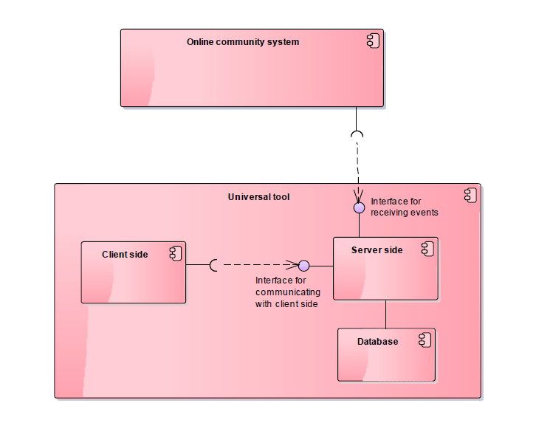
Img. 1: Component diagram of the tool concept

The server side is implemented in Java as a web service. The communication with it works through simple REST API. It uses three different databases that were tested separately. The databases are Oracle XE, PostgreSQL and a combination of Oracle XE with Redis.
The effectiveness of this tool was evaluated by utilization of a dataset from the Wikipedia system with the size of fifteen million events. While the performance of first two cases was decreasing significantly with the amount of received events, in the case of Oracle + Redis hybrid, the performance was constant for the whole test run. The results show, the use of NoSQL database was the right choice for this project. The average time of processing one event is around 1ms in this case.

References
- Brian Burke. Gamify : how gamification motivates people to do extraordinary things. Bibliomotion, Inc., 2014.
- Ashton Anderson, Daniel Huttenlocher, Jon Kleinberg and Jure Leskovec. Steering user behavior with badges. In WWW '13 Proceedings of the 22nd international conference on World Wide Web, pages 95-106, 2013.
- Caryn Swark. P2PU, Mozzila, Open Badges… oh my!, 2012.

* Supervisor: Ivan Srba, Institute of Informatics and Software Engineering

